Company |  | Страна | Specialization | Website
 | ALUNEXT | Russia | Manufacturing, sales and coating of aluminium profiles | http://alunext.ru/
 | VMK | Russia | Manufacturing and supplies of aluminium profiles | http://vmk-etm.ru/
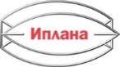 | IPLANA | Russia | Aluminium profiles and coating | http://iplana.ru/
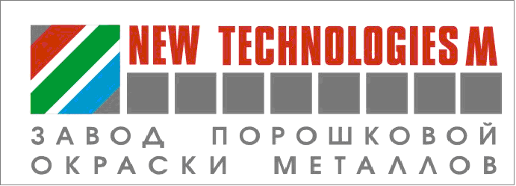 | NEW TECHNOLOGIES | Russia | Powder coating of aluminium | http://www.nt.spb.ru/
 | AKZO NOBEL LAKOKRASKA | Russia | Powder coatings for architectural applications | https://www.akzonobel.com/en/russia
 | PRIMATEK | Russia | Powder coatings | http://primatek.ru/
 | YAZPK | Russia | Powder paints | http://yazpk.ru/
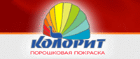 | COLORIT | Russia | Polymeric powder coating aluminum profile | http://www.mcolorit.ru/
 | PETROKON | Russia | Production and sales of extruded aluminium profiles | https://petrokon-spb.ru/
 | R.O.S.L.A | Russia | Surface finishing and supply of extruded aluminium profile | http://www.rosla.com/
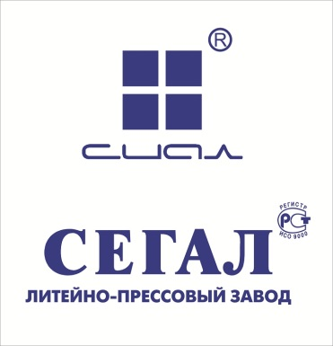 | SEGAL | Russia | Aluminium systems for architectural applications | http://www.sial-group.ru/
 | COMETAL ENGINEERING SPA | Russia | Development and production of complete extrusion lines and equipment for aluminum and its alloys. | https://www.cometaleng.eu/ru/
 | NEW TECHNOLOGIES M | Russia | Powder coating plant | http://www.nt.spb.ru/
 | KSK ENGINEERING | Russia | Equipment for powder coating | www.ksk-systems.ru
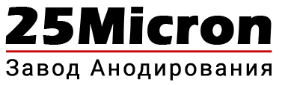 | 25 Micron Amodizing Plant | Russia | Aluminium anodizing | https://anodzavod.ru/anodzavod
 | AL5 | Russia | Manufacturing and supply of aluminium profile | http://al5factory.com/
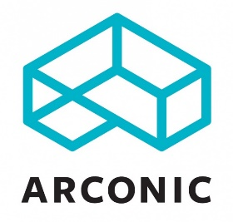 | ARCONIC | Russia | Manufacturing of aluminium semi-products | www.arconic.com
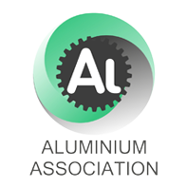 | ALUMINIUM ASSOCIATION | Russia | Association of  manufacturers,  aluminum suppliers and consumers | http://www.aluminas.ru
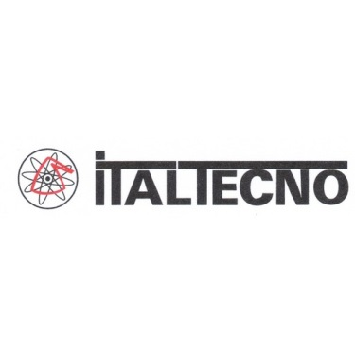 | ITALTECNO | Italy | Advanced technologies for aluminium | http://www.italtecno.com
 | CUBSON POWDER COATINGS | Spain | Quality label for decorative aluminum surface finish | /www.cubson.com
 | MANEL | Russia | Development and implementation of microarc oxidation technologies | http://manel.ru
 | Land Ametek (SPECTRO TS) | Russia | Sale, supply and maintenance of analytical equipment for laboratories and production control | http://spectrots.ru/
 | ALUFINISH | Russia | Surface treatment technologies | www,alufinish,ru
 | COIL S.A./N.V. | Belgium | Aluminium anodizing technologies | http://www.coil.be/en
 | MOSPRESS | Russia | Metal products manufacturing | http://www.mospres.ru/
 | INSTITUT FUER  Oberflächentechnik | Switzerland | International quality label | www.qualicoat.net
 | Литейно-прессовый завод «Сегал» | Russia | Production of aluminium profile | http://www.sial-group.ru
 | IGP Pulvertechnik AG | Russia | Corrosion Protection Technologies, Powder Coating Systems | www.igp-powder.com
 | Trasmetal SPA | Italy | Surface Finishing | https://www.trasmetal.net
 | Advenira Enterprises Inc. | USA/Russia | Unique liquid-based environmentally friendly SDN® coating materials. | https://www.advenira.com/
 | Metaltek Technologies Laboratory | Russia/Turkey | Research& Development laboratory ( Chemicals production) | http://metaltekkimya.com.tr
 | CO.M.P.E.S. S.p.A | Italy | Production of extrusion dies | http://www.compes.com
 | Gravis | Russia | Production of aluminium composite panels | http://www.gravis.ru/
 | Indexbox Marketing | Russia | Marketing Research | http://www.indexbox.ru/
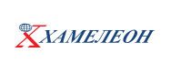 | Chameleon |  | Components, powder coating, laminations, metal structures | https://hameleon.ru/

